Useful gardening websites and apps

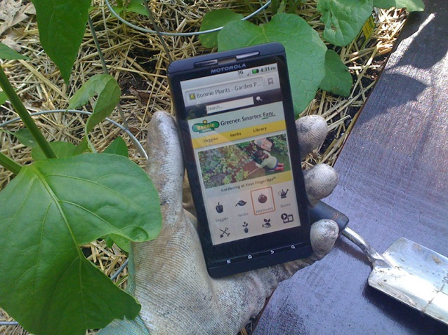
www.bgs.ac.uk/mysoil mySoil is a free app from the British Geological Survey and the Centre for Ecology & Hydro-logy. Find out your soil properties - type, organic matter, texture and pH - based on your area of the country.
www.growveg.com online Garden Planner which helps you grow fruit and vegetables to the best of their ability, whatever the size or shape of your garden or plot
https://app.gosprout.it gives you customized information and reminders at the right times throughout the growing season. No matter where you are or what type of garden you have, we'll help you go from planting to harvest
www.ukgardening.co.uk The UKGardening web site has been running since 1998. The idea behind the site has always been to provide what we think will be interesting and useful information for the novice gardener
www.thegardeningwebsite.co.uk a one-stop gardening directory where you can identify, search and quickly FIND everything and everyone you need to help design, build and enjoy your garden.
www.theenglishgarden.co.uk online magazine - The English Garden magazine features the most beautiful gardens from all across the UK and Ireland - both town and country plots, big and small. Inside, you will find invaluable practical advice from real gardeners, plantspeople and designers. There’s stunning photography from the world’s top garden photographers, as well as insightful writing from experts
www.gardenersworld.com – the magazine version of the TV program
www.my-garden-school.com - the world’s first virtual gardening school. It’s a unique global online horticultural classroom where you can study online gardening courses wherever you live in the world
www.frugalliving.about.com the largest source of expert content on the Internet – all about frugal living and gardening
www.rhs.org.uk UK charity established to share the best in gardening

