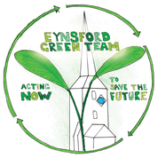
EYNSFORD IN BLOOM

Wildlife friendly hanging baskets
Why don’t you have a go at creating a wildlife friendly hanging basket this year? It makes good use of readily available plant material from gardens, provides suitable habitats for wildlife, and it is great fun (it really is!)

This hanging basket uses single flowers, which provide a colourful display that will provide plenty of food for bees and other pollinators. Hanging baskets often use bedding plants which are double-flowered, (more than one layer of petals) or are bred for long-lasting colour and don’t tend to have accessible pollen or nectar for wildlife.

The basket is lined with conifer clippings and lawn moss from the garden, rather than sphagnum moss, which is often taken from peat bogs. This provides hiding places for insects and is good for recycling.

You Will Need:
- Scissors and secateurs
- Hanging basket
- Multi-purpose, peat-free compost
- Conifer clippings
- Thatch and/or moss raked from your lawn
- Slow-release fertiliser
- Water-retaining granules
- Small circle of plastic and small flowerpot (see section on watering)
- (Purple chicken not required!)

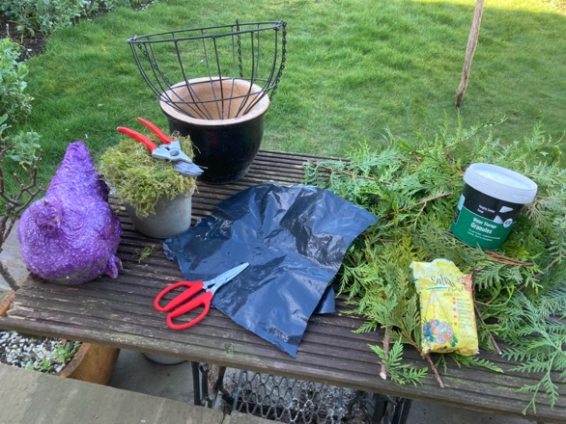

The recommended plants are available from garden centres, or on-line, but can also be sown from seed from February onwards. A selection of these plants would be adequate for one hanging basket.

Recommended plants for a summer hanging basket are:

- Bidens (yellow and white daisy like flowers; bees love this plant)
- Calibrachoa (also called ‘Million Bells’, these pretty plants come in a range of colours and attracts moths; from yellow to vivid pink)
- Diascia 'Little Dancer’ (this bright pink plant flowers from Spring through to Summer)
- Helitropium arborescens (also known as ‘Cherry Pie’ this plant is scented and is usually purple or white; we recommend ’White Queen’ or ‘Midnight Sky’)
- Lobelia erinus (this is a trailing variety of Lobelia, easy to grow from seed and is attractive to butterflies; a pretty variety is ‘Cambridge Blue’)
- Lobularia maritima (also called ‘Sweet Alyssum’, this plant has a sweet scent and comes in a range of colours; it attracts tiny, beneficial wasps that help control garden pests; we recommend a white variety such as ‘Snowdrift’ or ‘Sweet White’)
- Petunia (this annual bedding plant that attracts moths, is popular in hanging baskets and we recommend ‘Easy Wave White’ which is mound forming)
- Verbena ‘Termari’ (this is a trailing variety of Verbena; we recommend Burgundy, but it comes in a range of colours; butterflies like this plant)

Summer hanging baskets are best planted from April onwards, but they will need to be protected from frost. If you do not have a greenhouse, it is best to wait until mid or end of May.

Step 1. Lining the basket with conifer clippings and moss

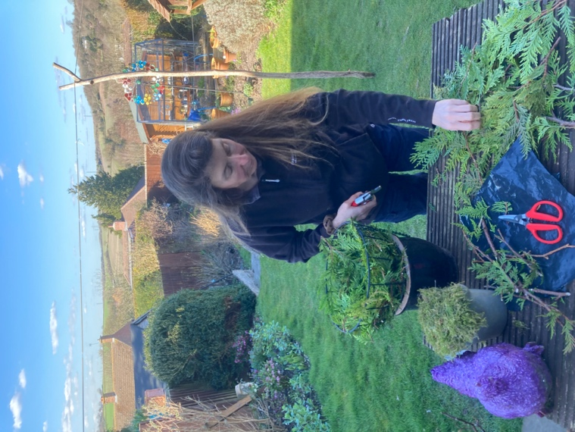

Firstly, line the basket with the conifer clippings. It helps to stand the basket in a terracotta pot to hold it steady whilst you work on it. I took cuttings of conifer from my neighbour’s hedge (after asking her permission first). Add a thick layer of material to create a solid base for the basket.

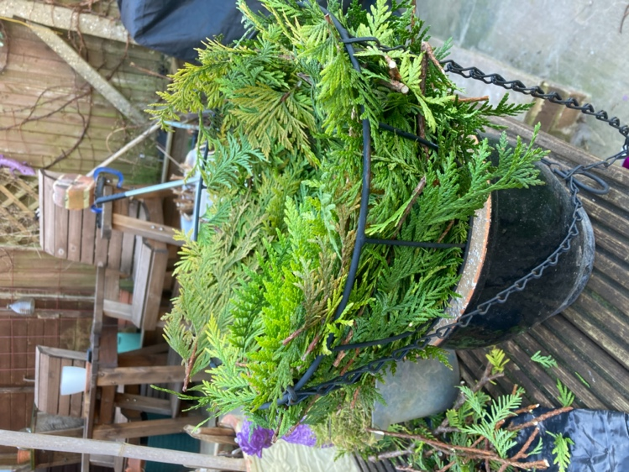

Then add the moss.

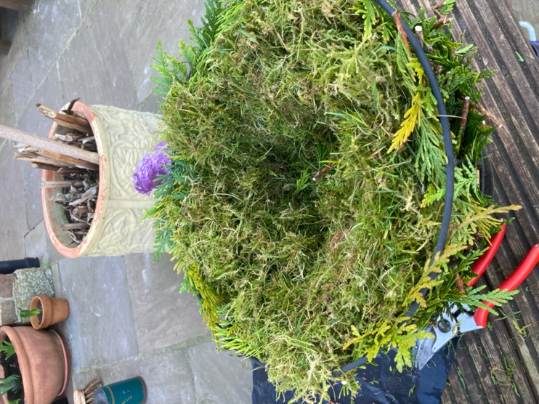

At this stage the basket doesn’t need to look neat and tidy!

Step 2. Lining the basket with recycled plastic, to conserve moisture, and trimming the foliage

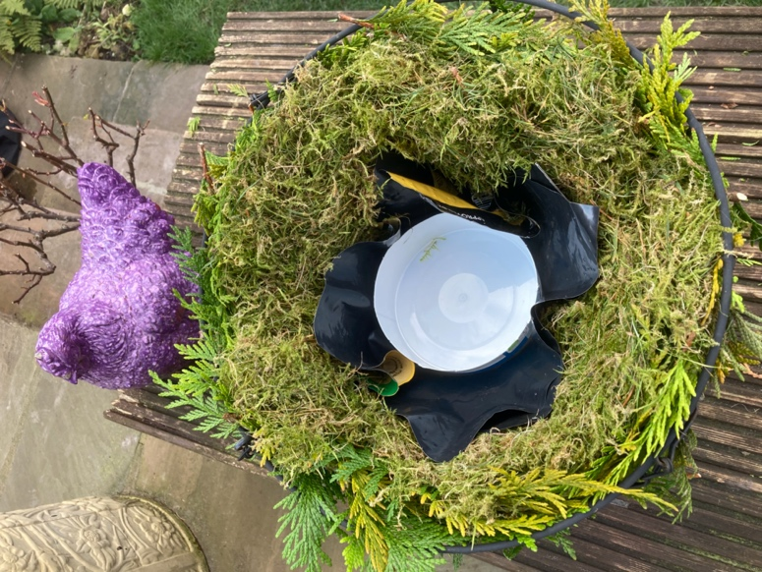

To help with water retention, add a couple of pieces of plastic (cut from an old compost bag or similar) to help retain moisture in the basket. Hanging baskets tend to dry out more quickly than other types of container and water can easily be wasted from them. Pierce a couple of drainage holes in the plastic, to avoid waterlogging. In addition, a small circle of plastic can be placed (cut from a yoghurt pot or similar) in the bottom of the basket before filling with compost to create a saucer that will help stop water running straight out of the bottom.

Once this is done, trim the edge of the conifer foliage to create a neat finish. More foliage can be added at this point where needed.

Step 3. Filling the hanging basket

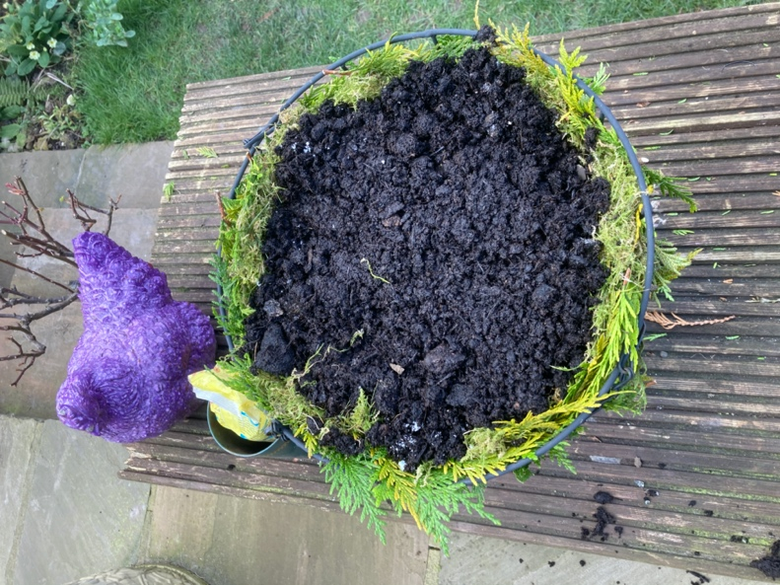

Fill the basket two-thirds full with compost. Don’t forget to add slow-release fertiliser to encourage growth and water-retaining gel to ensure the compost stays moist.
The basket is ready to plant up.

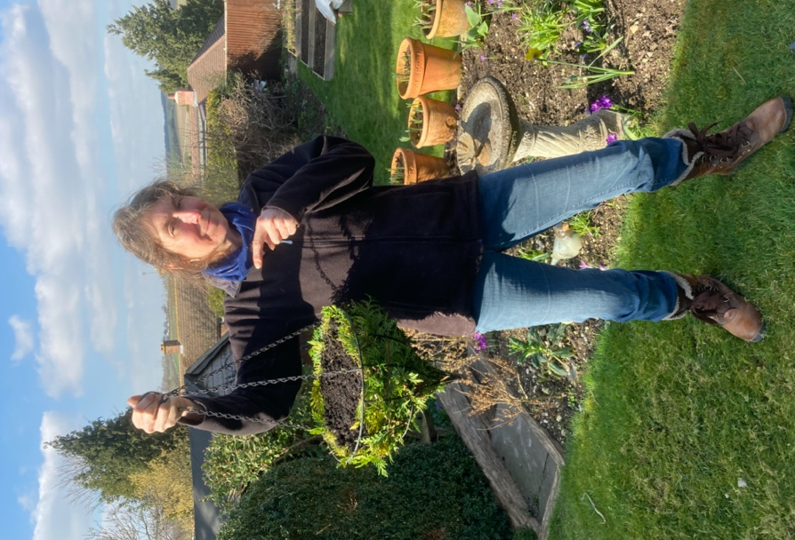

Step 4. Planting the hanging basket

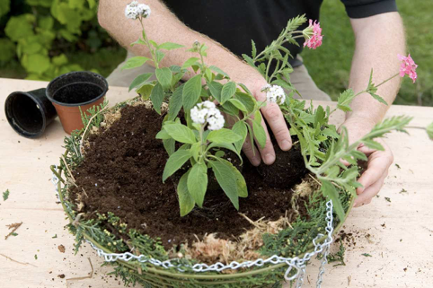
Image from www.gardenersworld.com

When you begin to arrange the plants in the basket, it is usually easiest to start with central upright plants, such as the heliotrope and lobularia, in the middle first. This can be used to create structure and impact.

Around this, position some trailing plants (such as lobelia and verbena) to cover the sides of the basket, particularly if it is made from wire. Space the plants evenly and fill any gaps with more compost.

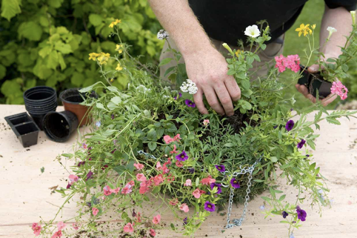
Image from www.gardenersworld.com

Step 5. Watering the hanging basket

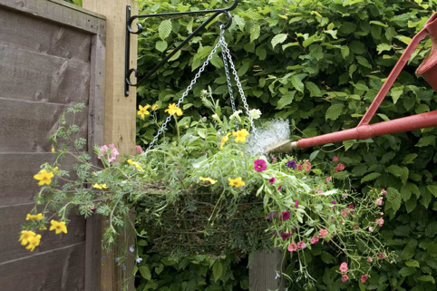
Image from www.gardenersworld.com

Once all the plants are in position, carefully fill around the rootballs with more compost, firming gently, so that you don't leave any large air gaps. Your basket is now ready.

Water well, but slowly, so that the water doesn't run out of the bottom of the basket (but don’t water it until you’ve hung it up, because that will make it heavy and awkward to lift!). Check baskets every day in summer, watering always unless the compost is wet. Plants grow better with rainwater, especially if you plan to use soluble feed so avoid using mains tap water if you can. Depending on the type of plants and compost that you have used, the plants may need feeding. On hot days it is recommended to lift the hanging basket (if not too heavy) and place it in a tub of water to give it a good soaking.

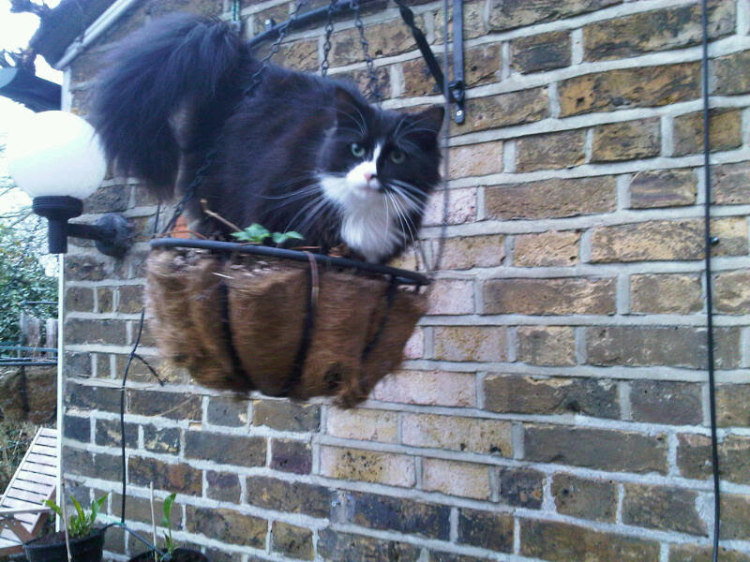 Unfriendly wildlife hanging basket!

Inspiration for this project was taken from the following: https://www.gardenersworld.com/how-to/grow-plants/wildlife-friendly-hanging-basket/.

